Year 11 Mathematics Methods

**Test 2 2023**

**Section 2: Calculator assumed**

Name: __________________

**Time Allocation: 30 mins Marks: _________/ 28**

***Show all your working clearly,*** *in sufficient detail to allow your answers to be checked and for part marks to be awarded for reasoning. Calculators are permitted.*

### 1.

In a 12-question examination paper there are 4 questions on trigonometry. In how many ways may a candidate select 8 questions if:

a) no restrictions apply?

b) no trigonometry questions are to be attempted?

c) exactly 3 trigonometry questions are to be attempted?

d) at most 2 trigonometry questions are to be attempted?

[1 + 1 + 2 + 3 = 7 marks]

2.

Find the natural domain and corresponding range of the function $y=\frac{x+3}{{(x-2)}^{2}}$ (Hint: display the graph on your calculator).

[2 marks]

3.

A linear relationship exists between the profit *$P* made from operating a tour bus and *n* the number of empty seats. A graph shows the line passing through the points (8, 720) and (21, 486). If the rule is $P=kn+C$:

a) Calculate the value of *k* and *C*

b) How many empty seats are there if no profit is made?

[2 + 1 = 3 marks]

4.

For $f\left(x\right)=3x-1$, $g\left(x\right)=2x^{2}-3x+11$ and $h\left(x\right)=3x^{2}-10$, determine each of the following:

a) $f\left(3\right)+g(12)$ b) $h\left(a\right)=14$

c) $g\left(p\right)=h(p)$

[1+ 2+ 2 = 5 marks]

5.

Find the value(s) of r given that:

$${}_{}^{12}{C_{2r}^{}}={}_{}^{12}{C_{r-3}^{}}$$

[ 2 marks ]

6.

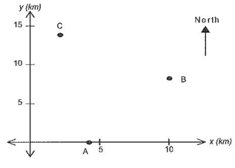

The accompanying diagram shows the location of landing beacons that guide aeroplanes onto the main runway. Beacons A, B and C are located at (4,0), (10,8) and (2,14) respectively.

Aeroplanes which land at the airport are required to fly along the path AB and then turn into the path BC which leads to the main runway.

a) Find the distance between the beacons A and B, B and C.

b) Determine if a school located at (5.5, 2) is directly beneath the flight path of planes attempting to land at this airport. Show your method clearly.

c) Show that planes attempting to land have to make a 90o turn from AB to BC.

[2 + 4 +3 = 9 marks]

**END OF SECTION 2**